
ANNUAL
Williamston
High Band
Mattress Sale Fundraiser!

- All sizes available!!!
- Pillow-top, Orthopedic, Latex, Memory Foam & Gel Beds!
- All items are BRAND NEW with Factory Warranties!
- Quality NAME BRAND Mattresses like Simmons!
- Free Layaway Available!
- Delivery Available!
- Cash, Checks and Credit Cards Accepted!




Profits Go Directly to the Band!

IF YOU NEED A MATTRESS SET,
NOW IS THE TIME TO BUY!!!

SAVE 30-60% OFF RETAIL!!!

WHEN: Sunday, March 9, 2014
WHERE: Williamston High School
Time: 12pm – 5pm
Like us on Facebook at
“Williamston High School Mattress Sale Fundraiser”

SAVE AN ADDITIONAL $50.00 OFF
ANY MATTRESS SET
Over $500 WITH THIS COUPON &
HELP THE BAND!!! Personally Invited By:____________________

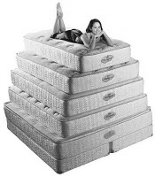

Questions Contact: Mike 616-281-5575 mwcfs@yahoo.com

